[**Patient Name**

Patient address Line 1

Patient address Line 2

Patient address Line 3]

22 June 2020

**IMPORTANT: PERSONAL**

**Your NHS number: [NHS NUMBER]**

**This letter will soon be available in different formats and languages on GOV.UK. For audio, braille, large print call RNIB on 0303 1239999.**

Dear [Patient],

**IMPORTANT ADVICE ON CORONAVIRUS (COVID-19)**

The Government advice for those shielding in England is changing soon**.** For now, you continue to be advised to follow the shielding guidance rigorously**.** This letter explains how the guidance is changing, why it is changing and what the change in advice means for you.

We know that shielding has not been easy for you and anybody living with you and we would like to thank you for your resilience over the last few months. However, it has been important for you to shield while the virus was widespread. Thankfully the number of people with the virus, and so the risk to you, is coming down.

**What is the current guidance?**

Over the course of the last three months, you have been identified as someone who is clinically extremely vulnerable due to an underlying disease or health condition that may put you at risk of severe illness if you catch Coronavirus (also known as COVID-19). This remains the case and you are advised to follow the shielding guidance rigorously.

You were advised to ‘shield’ to protect yourself during the peak of the epidemic in England when you were more likely to come into contact with the virus in your daily life. The initial shielding guidance advised that you should stay at home at all times and strictly avoid non-essential face-to-face contact.

On 1 June the shielding guidance was slightly relaxed, and we suggested that you may wish to spend some time outdoors away from your home once a day. This change was based on scientific evidence that the initial peak of the pandemic had passed in the UK and, in general, the likelihood of meeting someone in the community with infection had significantly reduced. Like all our guidance to those who are clinically extremely vulnerable, this was advisory. The current guidance can be found online at GOV.UK.

**What is changing?**

Throughout the epidemic we have been clear on the need to balance the risk of the disease to those who are clinically extremely vulnerable with the benefits of gradually returning to normal life. We know that the shielding guidance has been challenging to follow and that it will take time to adjust.

The latest scientific evidence shows that the prevalence of disease across all English regions has continued to decline. If this trend continues as we expect it to, the Government will further relax its shielding advice in two stages on **6 July and 1 August.**

**From 6 July:**

* you may, if you wish, meet in a group of up to 6 people outdoors, including people from different households, while maintaining strict social distancing;
* you no longer need to observe social distancing with other members of your household;
* in line with the wider guidance for single adult households (either an adult living alone or with dependent children under 18) in the general population, you may from this date, if you wish, also form a ‘support bubble’ with one other household. All those in a support bubble will be able to spend time together inside each other's homes, including overnight, without needing to socially distance. This is a small advisory change that brings those affected a step nearer others in their communities. However, all the other current shielding advice will remain unchanged at this time.

**From 1 August** the advice to ‘shield’ will be paused. From this date, the Government is advising you to adopt strict social distancing rather than full shielding measures. Strict social distancing means you may wish to go out to more places and see more people but you should take particular care to minimise contact with others outside your household or support bubble.

In practice, this means from 1 August you are advised that you no longer need to shield. This means that **from 1 August:**

* you can go to work, if you cannot work from home, as long as the business is COVID-safe;
* children who are clinically extremely vulnerable can return to their education settings if they are eligible and in line with their peers. Where possible children should practise frequent hand washing and social distancing;
* you can go outside to buy food, to places of worship and for exercise but you should maintain strict social distancing; and
* you should remain cautious as you are still at risk of severe illness if you catch Coronavirus, so the advice is to stay at home where possible and, if you do go out, follow strict social distancing.

More detailed guidance will appear on GOV.UK when the changes come into effect on 6 July and 1 August.

**Will the position be reviewed?**

After 1 August we will continue to keep your name on the Shielded Patient List. We will monitor the virus continuously over coming months and if it spreads too much, we may need to advise you to shield again.

We have committed to reviewing the advice to those who are clinically extremely vulnerable at every review point of the wider social distancing measures. Should the scientific evidence require the Government to tighten the advice for clinically extremely vulnerable people, this will be communicated to you quickly and clearly.

**Why is the guidance changing?**

The Government’s guidance to those most at risk of severe illness if they catch Coronavirus has always been advisory and based on the balance of risk to this group at a time when the transmission of Coronavirus has been highest in our communities. We recognise everyone will feel differently about their own risk and have different priorities – our ambition has been to help and support you in looking after yourself through a very challenging period.

All Government decisions on shielding advice are led by the latest scientific evidence. The latest evidence shows that the chances of encountering Coronavirus in the community has continued to decline. Four weeks ago, around one person in 500 had the virus. Last week it was even lower with less than one in 1,700 people having the virus. As a result, we believe that the time is now right to relax our advice to those shielding further, but we understand that it might take a while to get back to routine daily life again.

**Support to stay at home**

If you are in receipt of Government provided food boxes and medicine deliveries, you will continue to receive this support until the end of July.

This will give you time to prepare for new advice that you can visit shops, including supermarkets, as you did before the shielding programme commenced, provided you follow strict social distancing. We also recognise that, for some, this adjustment will take time. We can confirm that seven supermarkets have given you access to priority supermarket delivery slots, and these will continue beyond the end of July for those already signed up for support.

If you have yet to register for support, please do so online at GOV.UK or call 0800 028 8327 before 17 July so that support can reach you in time.

Local councils have also been providing support to those shielding. This has included a wide range of help to enable you to safely stay in your home, such as phone calls to reduce loneliness and meeting special dietary requirements. In order to help people adjust, local councils will continue to provide these services to those who need them until the end of July.

If you are struggling as a result of Coronavirus please visit [www.gov.uk/find-coronavirus-support](http://www.gov.uk/find-coronavirus-support). If you do not have internet access, please contact your local council who will be able to signpost you to available support.

**NHS volunteer responders**

Support will continue to be available through the NHS Volunteer Responder Scheme beyond the end of July. NHS Volunteer Responders can support you with:

* collecting shopping, medication (if your friends and family cannot collect them for you) or other essential supplies;
* a regular, friendly phone call which can be provided by different volunteers each time or by someone who is also shielding and will stay in contact for several weeks; and
* transport to medical appointments.

Please call 0808 196 3646 between 8am and 8pm to arrange support or speak to your health care professional for transport support. More information is available at www.nhsvolunteerresponders.org.uk.

**Going back to work**

You should discuss your situation with your employer and agree a plan for returning to work if you cannot work from home. Your employer may need to make adjustments to help you continue to work. Please go to [www.gov.uk/access-to-work](http://www.gov.uk/access-to-work) for more information.

Separate Government guidance has been issued on how employers can make workplaces COVID-safe including how they can maintain social distancing and a system of risk management in your workplace.

You will be able to use this letter as evidence for your employer to show that you cannot work outside your home until 31 July, including for statutory sick pay purposes.

**Accessing NHS services**

You should continue to access the essential services that you need, and you should contact the NHS if you have an urgent or emergency care need.

If you have ongoing appointments scheduled for care and treatment your GP surgery or hospital clinic will contact you to confirm the most appropriate arrangements.

**Mental health support**

It is normal during these uncertain and unusual times to feel anxious or feel low. You can go to Every Mind Matters (www.nhs.uk/oneyou/every-mind-matters) and GOV.UK for advice and tailored, practical steps that you can take to support your wellbeing. If you are still struggling to cope we would urge you to speak to a GP.

If you have any of the symptoms of coronavirus (COVID-19) (a new continuous cough, a high temperature, or a loss of, or change in, your sense of taste or smell), you must self-isolate at home and arrange to have a test to see if you have COVID-19 – go to the NHS website to arrange a test or contact NHS 119 via telephone if you do not have internet access.

Yours sincerely,

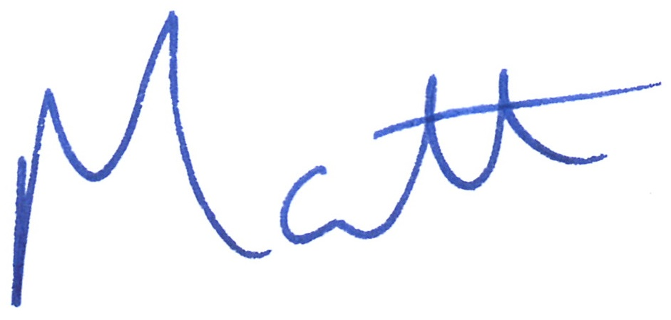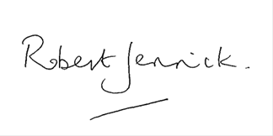

**MATT HANCOCK** **ROBERT JENRICK**